Bryan Twins Win Another Honor, Great For Men’s Doubles
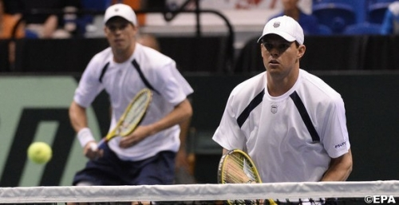
Li Na and the Bryan brothers have two more trophies to add to their collection after winning the International Tennis Writers Association’s top awards. The women¹s world #4 and the men’s top doubles team have been voted ITWA’s Ambassadors of the Year. It is the first time they have won the awards.
The awards recognize a combination of achievements on the court, conduct that shows tennis in the best possible light and co-operation with the media. ITWA represents the world¹s leading tennis journalists.
Li, who became the first Asian player to win a Grand Slam event singles title when she won the 2011 French Open, enjoyed another successful year in 2013. She has been a pioneer for tennis in China, which has been one of the sport¹s major growth areas. She was presented with her award at Melbourne Park Saturday.
Bob and Mike Bryan enjoyed one of their most successful years in 2013, winning three Grand Slam event titles and dominating the doubles scene like never before. Paul Newman, co-president of ITWA, said: “Li Na and the Bryan brothers both had excellent years on the court, but they have also been great ambassadors for tennis. Because of their success there are big media demands on their time and both have handled this with great professionalism. They set a very good example to their fellow players.” Written by: Bob Larson Tennis on 14th January 2014

