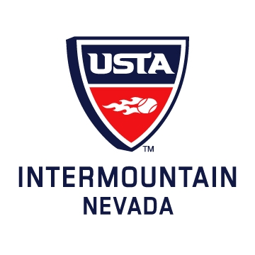
USTA Nevada Tennis Association
1333 N. Buffalo, Suite 130
Las Vegas, NV 89128

Tel: 702-792-8384
Fax: 702-792-8737
Web: nevadatennis.usta.com

2010

ANNUAL
USTA-NEVADA
BOARD OF DIRECTORS
MEETING

TUESDAY, JANUARY 18, 2011

USTA-NEVADA TENNIS ASSOCIATION
2010 ANNUAL REPORT

TABLE OF CONTENTS

2010 ANNUAL MEETING AGENDA

USTA-NEVADA TENNIS BOARD OF DIRECTORS

PRESIDENT’S REPORT

EXECUTIVE DIRECTOR’S REPORT

TREASURER’S REPORT

DISTRICT LEAGUE COORDINATOR’S REPORT

JUNIOR PROGRAMS COORDINATOR’S REPORT

COMMUNITY TENNIS & DIVERSITY COORDINATOR’S REPORT

USTA-NEVADA STAFF 2010

MEMBERSHIP INFORMATION

USTA Nevada Tennis Association
1333 N. Buffalo, Suite 130
Las Vegas, NV 89128

Tel: 702-792-8384
Fax: 702-792-8737
Web: nevadatennis.usta.com
Board of Directors Meeting
January 18th, 2011
6:00pm

Agenda

I. Call to Order

II. Roll Call

III. Approval of Last Meeting’s Minutes

IV. President’s Report

V. Executive Director’s Report

VI. Treasurer’s Report

VII. Committee Reports

VIII. Unfinished business

- New Business

X. Adjournment

AGENDA

2010 USTA-NEVADA TENNIS ASSOCIATION
ANNUAL MEETING
January 18, 2011
6:30 P.M.

CALL TO ORDER

ROLL CALL

APPROVAL OF LAST MEETING’S MINUTES

PRESIDENT’S REPORT

EXECUTIVE DIRECTOR’S REPORT

TREASURER’S REPORT

COMMITTEE REPORTS

UNFINISHED BUSINESS

NEW BUSINESS

ADJOURNMENT

USTA-NEVADA TENNIS ASSOCIATION
BOARD OF DIRECTORS
2010

Tim Blenkiron, President Gordon Hammond
Claire Roth, Treasurer Andres Borowiak
Rob Kirkendall, Vice Pres. Mike Grabowski
Glen Alex, Secretary Jon J. Jannotta
Dr. Jaldeep Daulat Rea Melanson
Ronald Holmes Muhammad

USTA-NEVADA TENNIS ASSOCIATION
BOARD OF DIRECTORS
2011

Tim Blenkiron Andres Borowiak
Claire Roth Mike Grabowski
Rob Kirkendall Rea Melanson
Glen Alex Dr. Jaldeep Daulat
Adolph Huddleston Jon J. Jannotta
Ronald Holmes Muhammad

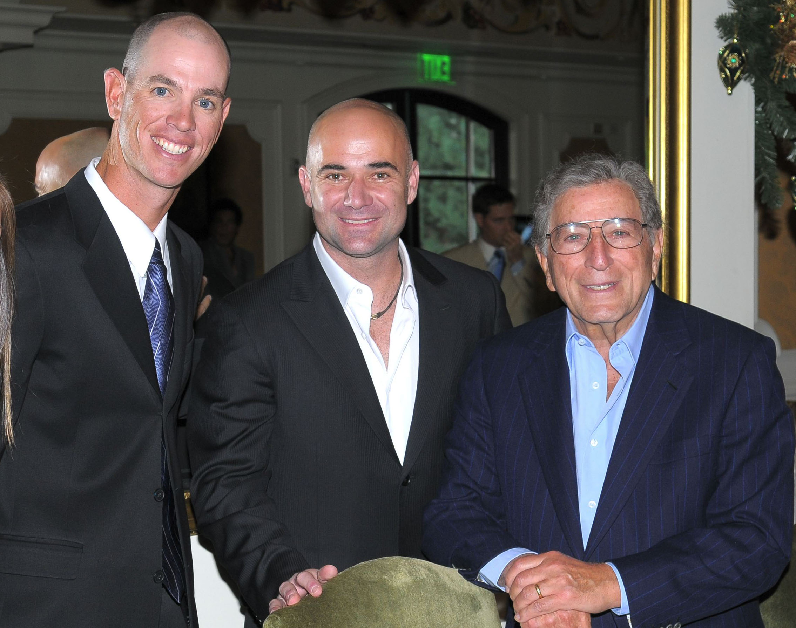

President’s Report

Through the leadership and hard work of Ryan Wolfington, our Executive Director, and his staff, the USTA-Nevada District once again had a record year. In the past two years we have the highest net profits, membership and league numbers in our organization’s history!

When we began the restructuring process 6 years ago, we had a reserve of around $50,000. Now we have over $212,000, improving our financial stability as an organization tremendously. During that same time we went from 3,810 members to an all time high this year of 4,321. We also went from 5,285 league entries to an all time high of 6,261, which included a record breaking 21% increase in league growth last year compared to the Section average of around 3%. In 2010 we were able to maintain this growth and increase benefits to captains and players through our new player parties and awards banquets.

In addition to record breaking increases in participation and membership, USTA-Nevada had the largest net profit we have ever experienced last year and the second largest this year. Furthermore, our total expenses for the last two years are lower than any previous year going back to 2003. Our staff was able to increase services, events, programming and net profits while decreasing expenses, all during the worst financial recession in our state’s history.

Our excellent financial performance will allow us to use the proceeds and invest in our organization’s mission to grow the game of tennis. This will be done by continuing our goal of providing members with more community events that bring us all together, coupled with a new 10 & Under initiative to get children started in the game as early as 3 years old. This is an investment in the future of tennis. We hope the whole community can work with us by continuing to participate, volunteer and support these efforts. I want to make a special thank you to our Board of Directors who have worked so hard to help bring the organization to where it is today. We can not say enough about Ryan Wolfington’s leadership and hard work, as well as that of his USTA-Nevada staff.

I encourage everyone to participate in our organization as we continue to take our service to the community to a whole new level.

Sincerely,

Tim Blenkiron
President
USTA-Nevada

USTA Nevada Tennis Association
1333 N. Buffalo, Suite 130
Las Vegas, NV 89128

Tel: 702-792-8384
Fax: 702-792-8737
Web: nevadatennis.usta.com

2010 EXECUTIVE DIRECTOR ANNUAL REPORT
(To be made part of the minutes)

Dear Pros, Captains and Members:

The teaching professionals, captains and community partners are the lifeblood of our organization. All accomplishments we are able to facilitate are a direct result of their efforts. That being said, I am very proud of our Staff and Board for helping us achieve record breaking numbers in membership, league participation, and net profits for the last two years.

Our agenda has been very aggressive and filled with a lot of work and fun! A few of this year’s highlights include: an organization wide sponsorship by Connections Academy and Tactik; our high-end Awards Banquet for juniors; and the Adult events at LAVO and TAO nightclubs. We also provided or co-sponsored countless other giveaways and events for our pros, captains and members, including the UFL pro football tickets, player parties, Rob Kinas events, and more.

Our Hispanic outreach campaign with Telemundo has been very successful, with over 200 players responding to our Spanish speaking ads. Our schools programs continue to grow as we strive to bring middle school tennis back to our state. Our advocacy initiatives have been extremely successful in bringing the Regional Training Center to Las Vegas, as well as a coaches training pilot program for elite 10 and under players. Never have we had so many pros in one location working together--ever!

We continue to improve our marketing and promotion with the Inside Tennis magazine, two new radio shows, the E-Newsletters, the first ever tournament poster and Grand Slam series ranking system.

We are proud to have signed an exclusive hotel deal with the Las Vegas Hilton as our official hotel and TAO and LAVO as our official nightclub and restaurant. We are thankful to CourtThink and Red Rock Country Club for their efforts to bring professional tennis back to Las Vegas. Equal credit goes to the Darling Center, Canyon Gate, ITC, The Ridges and Las Vegas Hilton for hosting some very special programs with the world’s best players including Mats Wilander, the Bryan Brothers, Sam Querrey, Dave McPherson and Rick Leach.

Our volunteers have been a huge part of our success and we appreciate all of their efforts, especially our Board of Directors who have worked so hard to improve our organization. We are especially proud that two of our own, Sandy Foley and USTA-Nevada Treasurer Claire Roth, were chosen to be on National committees. Sandy and Tim Blenkiron were also selected to be on the USTA-Intermountain Section Board of Directors.

A special thank you to our President, Tim Blenkiron, who has helped lead our organization and the whole Intermountain Section to a more positive and unified future. Without the hard work and support of Tim Blenkiron and our entire Board, none of our accomplishments would have been possible.

In these difficult economic times we continue our cost cutting efforts and look to new sources of revenue, such as sponsorships and fundraising. If anyone has ideas, would like to sponsor or volunteer, please let us know. People like you make our goal to grow and promote tennis possible.

In closing I want to thank the staff: Rob Merriman, Mary Maragos, Diana Winn and Dann Battistone, who have accomplished so much. They are the heartbeat of our organization.

Sincerely,

Ryan Wolfington
Executive Director
USTA-Nevada District

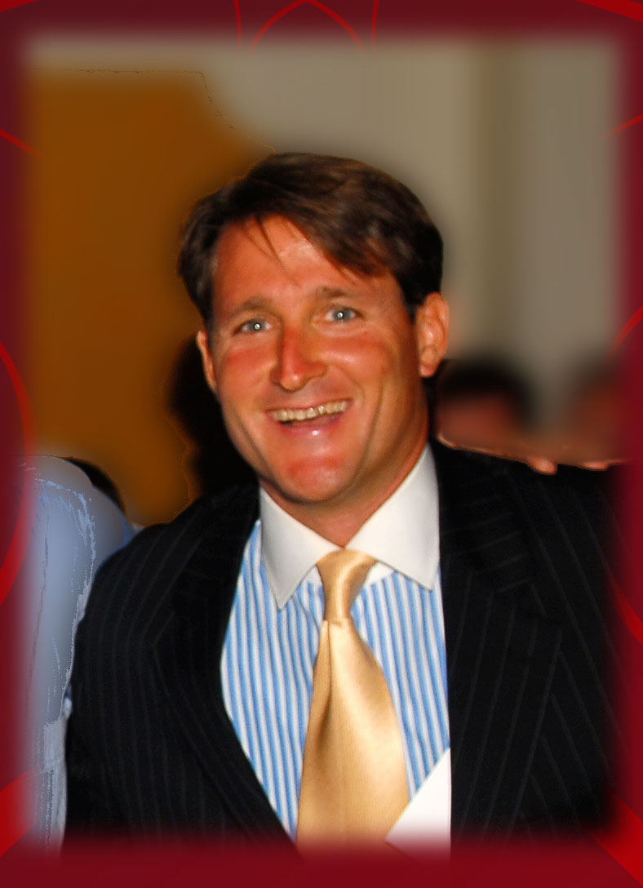
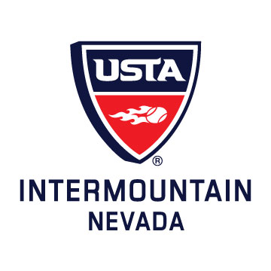
2010 EXECUTIVE DIRECTOR ANNUAL REPORT
(To be made part of the minutes)
This report includes an update on all of USTA-Nevada’s initiatives for the year 2010.

BUILDING COMMUNITY INITIATIVE

10 UNDER PILOT CAMP

The largest collection of USTA-Nevada pros ever assembled took place at the Darling Center and ITC for a USTA National 10 Camp Pilot Program.

“There are more pros in one place than I have ever seen in my 30 years,” said Jeff Foley.

200 people with close to 70 or 80 pros attended, including tennis directors, head pros, community and park pros, parents and elite juniors, as well as school P.E. and after school teachers.

This coaches’ training session on the latest training techniques for 10 Under High Performance teaching was a huge success. It also included a coaches’ training seminar, parents’ seminar and on court demonstrations and hands on exercises.

USTA National paid all of the expenses which included pros’ fees, equipment and court time. USTA-Nevada got sponsorship for all of the food and a discount on the courts, free meeting space and many volunteers to help. USTA-Nevada staff worked the event for free. We spent a significant amount of time calling, emailing and texting the pros to get the whole community out. Thirty-eight 10 under players were also treated to a day of free training!

QUICK START WORKSHOP

National USTA Staff held a Quickstart training session on the clay courts at Turnberry for free for all local pros, parents, teachers and tennis lovers who want to learn the new Quickstart programming ideas. We had over 50 people and pros attend. It was a big success.

BNP PARIBAS USTA-NEVADA TRIP

-We gave Indian Wells tournament a bye on 1st weekend due to past complaints
-Negotiated a discounted rate of $89 a night with nice hotel compared to $250 rate on hotwire
- USTA-Nevada members bought 70 plus tickets at a discounted rate
- 30 plus USTA Nevada members got the special hotel rate

INTERMOUNTAIN ANNUAL MEETING & USPTA ANNUAL MEETING IN LAS VEGAS

Tim Blenkiron and I offered Las Vegas as a site for the ITA Annual Meeting. Andre Agassi has agreed to do the ITA Hall of Fame and therefore the ITA Annual Meeting is being moved to Las Vegas for this February. This is great for Las Vegas!

USTA-NEVADA AND UNLV FREE TOURNAMENT

USTA-Nevada held a FREE Adult Tournament for the community. Lorenzi Park donated the courts. This was designed to bring the community together while also promoting tournament play. It was a great success.

WHEELCHAIR EVENT

-USTA-Nevada sponsored a wheelchair event at Terry Walters’ request for $500.
-The event was a success.
-I also got the Hennessy Foundation to donate close to $500.

PROFESSIONAL TENNIS

I spoke to Jeff with World Team Tennis to keep channels open to bring a pro event to Vegas.

I worked with Red Rock Country Club to promote and support the tournament. I personally sponsored the event and helped them to get other sponsors. We did a daily e-blast to promote the event as well.

UFL PRO FOOTBALL FREE TICKETS

I was able to get 500 free pro football tickets. I gave them out to clubs, pros and members.

LAVO AWARDS BANQUET

The LAVO Awards Banquet and end of year League party was a big success. We got free food and drinks donated for members. Clint Holmes was MC.

TAO CAPTAINS MEETING AND PARTY

We held the Captains Meeting at TAO nightclub. All captains received a free hooded sweatshirt. All league players were invited and got free food and drinks for 3 hours. All participants got free GODIVA chocolates as well.

JUNIOR AWARDS BANQUET & TENNIS BALL

We were able to avoid $6,000 in expenses again by getting VegasTennis.com’s Marty Hennessy Foundation to sponsor the Awards Banquet during their annual Tennis Ball. We had City Councilman Stavros Anthony attend and speak. 400 parents and juniors attended.

PUMPKIN CHECK-IN PARTY AND PARENT SEMINAR

The Pumpkin Tournament had a pot luck check-in party. The pot luck helped us avoid $3,000 in food costs. A world renowned nutritionist spoke to the families about diet and how food affects high performance athletes.

LADIES LEAGUE LUNCHEON

This year we opened the Luncheon up to all Ladies League players and partnered with the Las Vegas Lexus Open at Red Rock to hold it on “Super Saturday” of the Womens’ Pro Circuit Tournament when the semifinals are being played. All participants got 50% off tickets. It was a big success. We raised money for USTA programs and the League during the silent and live auction.

BRYAN BROTHERS CELEBRATION AT LAVO – NEW YORK

Bryan Brothers won the US OPEN. TAO and LAVO owner and I set up a celebration dinner and party for them at TAO and LAVO New York. I was able to invite top USTA staff and volunteers to this VIP event, which included Jay-Lo and Mark Anthony. The USTA staff was happy to attend and the Bryan Brothers had a blast. This strengthened the relationship with them.

NEW YORK AGASSI EVENT

USTA-Nevada helped promote a New York Andre Agassi event. He gave a talk about his life with Rick Reilly, the ESPN commentator. We were able to invite and or run into key partners like ITA Executive Director of all college tennis, David Benjamin and Frank Adams, USTA-Intermountain President, as well as Jon Messick, Intermountain’s incoming President. Dan Limbago and David Slade and Kevin Clayton were also invited. We took a photo and ran it in INSIDE TENNIS Magazine.

MARKETING INITIATIVE

INTERCOLLEGIATE TENNIS ASSOCIATION – EXECUTIVE DIRECTOR MEETING WITH CLAIRE ROTH

Claire is on the ITA board and set up a meeting with the ITA’s Executive Director David Benjamin when he was in Las Vegas.
-I tried to recruit their national and regional events to Las Vegas with some success.
-Discussed a summer series tournament or Spring Break tournament in Vegas likely to take place in 2011.

LEAGUE AD CAMPAIGN

We started a “We Need Players” ad campaign designed at inviting players to join League. This included ads in the magazine, PSA’s and e-blasts. We had an additional 90 responses the last time we did this.

HIGH PERFORMANCE INITIATIVE

REGIONAL TRAINING CENTER

-Tim Blenkiron and Saad Ashraaf at Darling Center have been selected to run the RTC.
-Big opportunity for local juniors who won’t have to travel to this in another state! BIG!
-This will lead to other grant and play opportunities for Las Vegas and local families.

LEADERSHIP BREAKFAST

We participated in four “Leadership Breakfasts” with local tennis players including Senator John Ensign. Phil Aurbach and Neil Tomlinson, both attorneys, shared their secrets to a successful life with local juniors. We did a breakfast with Agassi Foundation CEO Steve Miller. E-mail invitations were sent out to all local juniors on our list and 28 attended. VT Marty Hennessy Foundation paid for the cost of the breakfast as a sponsor. Charlie Palmer Group gave us the breakfast at cost and the room for free. We reached out to Meadows, Bishop Gorman and Dawson School as well.

NCAA RULES MEETING WITH PARENTS

Online schooled players must follow new NCAA rules or they will not be eligible to play in college. I held a meeting and shared my research with the families recommending they go with schools proven to be approved by the NCAA’s new rules. K-12, Connections and Odyssey were mentioned by name.

I gave them print outs of NCAA rules and approved courses from their website. We had 30 people at the USTA-Nevada office for this meeting. I explained that Laurel Springs was good but was no longer our sponsor, that Connections Academy was. I told parents to choose for themselves, as each school has their own benefits.

VANCOUVER TRIP

The Hennessy Foundation extended the invitation to all junior tennis players to join them in an all expense paid trip to Vancouver to play on “Team Vegas” against Vancouver in what they have dubbed the “Stanley Cup.” Nine players from the city went. USTA-Nevada had no financial involvement. Team Agassi, Darling Center and Hennessy Foundation had players attend.

ADVOCACY INITIATIVE

For all of our social events I send a personal letter and email out to our VIP list, which includes all state politicians, park and recreation leadership and key leaders.

This year I have met with fewer politicians to advocate for tennis because funding is way down so no tennis centers will be built. I did reach out to the following politicians:

-Senator John Ensign
-City Councilman Ricki Barlow
-City Councilman Stavros Anthony
-State Legislature
-Mayor Oscar Goodman

PARTNER ORGANIZATIONS AND PEOPLE

I have talked and gotten ideas from most of the pros and clubs in town. I also have talked to the following people about ways our District organization can partner and grow the game of tennis.

-Las Vegas Hilton CEO Dave Monohan
-Stratosphere CEO Frank Riolo
-Bob and Mike Bryan
-Wayne Bryan
-Actor Eduardo Verestagui
-USTA National staff Geoffrey Russell
-National USTA Board member Judge Valdez
-National USTA board member Carol Welder
-National USTA Staff High Performance
-Martin Blackman
-Telemundo Marketing Director
-National USTA Community Tennis Staff David Slade
-USTA National NJTL staff Dan Limbago and Emily Sandor
-Tenniswarehouse President Don Hightower
-Claudine Grant, FOX news reporter
-ITA Executive Director David Benjamin
-Entertainer Clint Holmes
-Newsman Kevin Janison
-New Vice President Rob Scott
-Incoming ITA President Jon Messick
-ITA Board Member Angela Emory
-Marriott International Steve Heitzner
-Attorney and tennis enthusiast Phil Aurbach
-Hilliary Heard, VT Marty Hennessy Junior Tennis Foundation – NJTL
-ITA Volunteers
-Kathleen Jansen, Nevada attorney and ITA volunteer
-Rob Kinas, Nevada attorney and extraordinary tennis sponsor and event coordinator
-Darian Borowiak, Agassi Foundation Sr. Staff
-NJTL leader Ray Benton
-Leon Vernon – NJTL
-Dr. Sid Franklin - NJTL
-Andre Agassi Foundation Director Adam Carey and Foundation Leadership
-Boys and Girls Club President and Chairman of Las Vegas
-Senator John Ensign
-City Councilman Stavros Anthony
-Agassi CEO Steve Miller
-BYU head coach Brad Pearce
-ED of Utah Linda Vincent
-ED of Colorado Fritz Garger
-ED of Idaho Mathew Warren
-ED of Montana Dave Boon
-USPTA President Ken Shioi
-Laura Wilson, Rep.
-YMCA Sr. Vice President
-Interns for video and admin work
-Staff and leadership at City, County and Henderson Parks and Rec.
-Darling Tennis Center
-Harvest Bread Company
-Whole Foods Marketing Director
-Fremont Middle School and Sig Rogich Principal
-Lower school principals
-Trader Joes Marketing Director

USTA NATIONAL STAFF TOUR

I took Geoffrey Russell to Darling Center, ITC, Lorenzi Park and a number of the Title 1 lower and middle schools . He was very impressed with the opportunities in Las Vegas.

DARLING CENTER – PRIVATIZING

We met with the City of Las Vegas to make sure the Darling Center stays open to the public. USTA-Nevada was part of the process. The City was very fair and we are happy that the Center is still available to League teams and tournaments.

CITY OF HENDERSON

-Met with the head of tennis for Henderson.
-Great opportunities to expand middle school tennis through Parks Department
-Spoke with staff about long term plans to create a tennis center
-Worked with staff to help them run park classes they needed help on
-Advocated for James Springer and Matt Springer’s programs; they are very successful

CLARK COUNTY PARKS AND RECREATION

-Sent out an e-blast to get tennis players to a tennis town hall meeting for the County
-Went to County tennis town hall meeting
-Advocated to promote tennis at Sunset

OPEN LETTER SUPPORTING ANDRE – INSIDE TENNIS

-The Board approved my open letter supporting Andre Agassi
-Andre called Tim to thank him
-Many people at USTA meeting commented on it
-Our job to thank Andre for all he has done to help Las Vegas
-Attended Agassi Grand Slam and wrote article supporting his work

AGASSI FOUNDATION

I attended the Andre Agassi School Open House with Claire Roth.
Claire set up a talk with USTA National Board Member Judge Valdez to speak at Agassi Prep. I attended and showed the Judge around.

AGASSI FOUNDATION MEETING AND NEWSLETTER

Andre Agassi Boys and Girls Club was talking about evaluating the Team Agassi tennis program to improve it. I had a meeting with their leadership to offer ideas and USTA support, which was very helpful.

The Foundation also used an article I wrote about the success of their program on the front cover of their Foundation’s newsletter. This was great exposure for the role of tennis in Andre’s Foundation.

BOYS AND GIRLS CLUB MEETING

I met with the President and Chairman of the Board of Boys and Girls Club in Las Vegas. I informed them of the great program they have at Team Agassi, of which they knew. They were so motivated they agreed to add tennis to all of their boys and girls clubs in Las Vegas. Adam Carey, who runs the Agassi Foundation, was pivotal in making this happen.

USTA NATIONAL NJTL COMPETITION IN VEGAS

In October Dan Limbago from USTA National worked with Agassi Foundation’s Adam Carey and myself to hold a NJTL competition and excellence camp in Las Vegas. We showed the teams from all over the USA a good time, took some coaches to Mr. Agassi’s home and to LAVO.

Adam Carey was also chosen to travel to the US Open as part of the Arthur Ashe Kids Day. Both of these opportunities were created as a result of the Agassi Foundation’s success. Congratulations to Adam for building this national relationship with the USTA.

LEADERSHIP BREAKFAST – AGASSI FOUNDATION CEO STEVE MILLER

Agassi Foundation CEO Steve Miller spoke at the Leadership Breakfast, which included youth from all over the country.

WARD 4 BUSINESS NETWORK MEETING

I was invited to be a part of City Councilman Stavros Anthony’s Business Network Committee, held at City of Las Vegas Durango Hills Community Center, operated by the YMCA. I was asked to be on their Board. I am considering it.

Met with YMCA Senior Vice President.

Sarah Toti and Ashley Newell both got scholarships to play college tennis early.

UNLV REGIONALS

Claire went to represent the USTA at the Regional Finals. She took a photo with the winners.

COMMUNICATION INITIATIVE

-I sent the Annual Report from last year to all members via Inside Tennis Magazine
-I sent the Annual Report for Captains, for pros, and for members to all groups via email and will do again this year
-Sent out quarterly tournament schedule reminders
-Sent out 2011 Tournament schedule via e-blast
-Published many articles on USTA-Nevada and partner site VegasTennis.com
-First tournament poster ever worked out well. Posted at all the clubs.
-Sent many PRO & CAPTAIN ALERTS to update them on important items
-Sent information letter to all junior parents and coaches about new RTC.

PRO MEETINGS

I have met with 20 or more pros to go over the USTA-Nevada Business Plan to get their feedback.

USTA NATIONAL AND SECTIONAL INITIATIVE

MEETING WITH KEITH BELL

Keith Bell from Intermountain came into town to see our Business Plan and to help us get prepared to apply for a TSR. We have established a very positive working relationship that I think will allow us to do a lot of great things. We established a plan to reach out to diverse markets, to make the USTA-Nevada community more inclusive. We also began talks about a new TSR.

SECTIONAL AND NATIONAL MEETINGS

-Tim Blenkiron and I, as well as Ron Holmes, Glen Alex and Claire Roth have made an effort to support and be productive at a Sectional and National level so Nevada is represented and informed. The most important element is meeting the people who make things happen and creating positive working relationships with Sectional and National leadership.
- I gave a great presentation on Nevada’s successes to the Sectional USTA Annual Meeting.
-I sent our Annual Report to Sectional and National leaders.
-We received a lot of positive feedback
-Tim Blenkiron and I worked hard to advocate for positive change and a unified vision within our Section. These efforts have resulted in a lot of positive change.
-We have created a pathway for volunteers to get active locally, then Sectionally, then Nationally.
-In 25 years only two people have ever been on National committees: Sandy Tueller and myself. This past year two people from Las Vegas were on National committees, which is very impressive: Sandy Foley on the Adult Competition and Claire Roth on Junior Comp.

BUSINESS DEVELOPMENT INITIATIVE

EXCLUSIVE HOTEL

-Sent an RFP to top hotels in Vegas
-Offered exclusive Strip and Summerlin rights to our events and assistance in getting non-USTA events at Darling, etc.
-Met with Darling and UNLV and Hennessy Foundation who all run National events and agreed to let me bargain for them collectively
-Marriott, Venetian and Hilton submitted proposals
-Staff voted on the hotel without comment from me at our staff meeting
-Staff voted the best proposal was the Hilton for the Strip and Marriott for Summerlin

SUPPORTING PROS & CAPTAINS INITIATIVE

THANK YOU GIFTS AND EVENTS

-Captains and pros were given free football tickets
-Captains got free hoodies with USTA logo
-LAVO, TAO parties
-Sent District League Championships photos to all captains and team players for Spring League
-Special table and free entry to Ladies League Luncheon

ADULT LEAGUE

Met with Sandy Foley and Mary to solve the issue of Captains having to schedule their own matches and the size and schedule of Adult League. Sandy recommended flights, raising League fees and not having Captains schedule their own matches whenever possible.

WEBSITE

-Website additions to add clubs’ information went into effect this year. Now any club can post all of their information on the site.
-“Click to play” button added on website so people looking for tennis can fill out form
-Regional referral system created that sends all persons requesting facility information a list of facilities in their region. This inspires fairness and confidence.
-New website survey functions have helped us

PROFESSIONALIZING THE BOARD INITIATIVE

AWARDS NOMINATIONS

A new process helps us professionalize the Awards Nomination process.

-All awards were listed in a nomination form with the description of the award.
-All past winners will eventually be added to this for our archive
-The award nominations go out via email or via online form
-Award Committee made up of staff will choose award winners

BOARD ORIENTATION

-USTA-Nevada new Board Member orientation took place within a month of being elected.
-I met with our new Board Members, Rob Kirkendall and Glen Alex, and updated them on all aspects of our Strategic Plan and Business Plan.
-I will meet one more time to go over some Board governance materials

EMPLOYEE PROCEDURE AND POLICY MANUAL

We have had the policy manual in place for years. This past year we instituted a new Procedures Manual for each job. This way if a new person were to come into the job, there would be a “How To” that is detailed and simple, explaining all the tasks and procedures related to that specific job. Some are more in-depth than others, but the basic outline has been achieved for each job. These archive and Procedure Manuals have helped staff to see their roles more clearly. The Manuals also insure continuity in case a staff person moves on and has to be replaced.

USTA-NEVADA ARCHIVES

I went through the archives and discovered the following:
- Our Minutes, Board meeting procedures, ED Reports and Annual Reports are far more in depth and more professionally written then any others in the past 10 years.
- I archived all of our Annual Reports so they are easy to find in a binder instead of buried in boxes in storage
- I have archived all ED Reports in a binder
- I did a 10 year financial analysis that resulted in the following results:
-USTA-Nevada’s net profit in 2009 is 2.5 times larger then any year in the organization’s history and 2010 looks close to the same.
-This year’s expenses are lower than every year dating back to 2002
-Net income has increased over 25000 percent in 2009
-We are archiving committee meeting notes as well.

AUDIT

The audit done by the Intermountain’s accounting firm confirmed that all our books and records are correct and show everything is doing well.

-The Auditor’s letter is available to the Board

BONUS POLICY

This past year we established our first set of guidelines for determining if and how staff bonuses will be distributed each year. These guidelines were the culmination of much research and debate by the Board. The Board feels bonuses are good to celebrate, reward and incentivize staff. They are also good to augment the staff’s otherwise modest salaries due to being a small non profit.

USTA COMMUNITY DEVELOPMENT WORKSHOP

Tim Blenkiron and I attended the Community Tennis Workshop. This workshop was focused on organizational governance. We found out our organization was in compliance with all of the latest requirements by the IRS and non profit management standards.

We saved money by sharing a room which ITA paid for. We achieved the following:
Spent much time building positive relationships with USTA National staff, including dinner with David Slade, the National Manager for Community Tennis, Karen Ford and ITA Board members and key volunteers.

DIVERSITY INITIATIVE

-Assisted in helping families and programs apply for diversity grants
-Set up a NJTL State leadership meeting attended by Dan Limbago and all of the NJTL’s in Nevada
-Helped promote the Hispanic Ad campaign
-Met with Latin Chamber of Commerce
-Put together Diversity Plan with Keith Bell, ITA staff in charge of Diversity
-Helped administer and set up programs in title 1 schools and in diverse areas
-Helped recruit Diverse umpires
-Inspired Diversity on the Board and on committees
-Held in office Diversity discussions
-Reached out to diversity vendors for printing

VOLUNTEER INITIATIVE

Recruited countless volunteers including interns
-Interns include:
Video intern
Graphics intern
Marketing intern
Sponsorship intern

Our internship program has given college and high school students an opportunity to learn, augment their resume and get experience. In return we get some high level help.
The internship was highlighted by our two sponsorship interns who competed in a “Vegas Tennis Apprentice” competition that resulted in them getting $16,000 worth of items donated for our raffle and silent auction!

VEGAS TENNIS APPRENTICE

Division 1 college players Dillon Berkabile and Edgardo Ureta spent the summer interning part time for USTA-Nevada. Both participated in what I called “Vegas Tennis Apprentice,” allowing them to pick 5 local juniors to help each of their teams to go out and get as many items donated for our raffle and Ladies League Luncheon as possible. The two of them combined got over $16,000.00 worth of items donated (based on retail value).

PROFESSIONAL TOURNAMENTS INITIATIVE

We partnered with BNP Paribas, International Tennis Hall of Fame and SAP OPEN to promote their events in Las Vegas. Each of these organizations gave something back to the USTA-Nevada is the form of discounted or free tickets for our raffle.

FUNDRAISING INITIATIVE

CITY WIDE RAFFLE

We partnered with VT Marty Hennessy Foundation to get raffle items and tickets printed. Any club, pro, captain, junior family can use our community wide raffle tickets to raise money for their cause. This was extremely successful.

LEVEL 3 NATIONALS – JR. CHANGES

National cut back national level 3’s to make it more competitive, to cut back travel costs for families and to inspire a “earn your way” philosophy on the National Championships level.

Nevada retained their levels 3’s due to the West and Intermountain not having many level 3’s already. Nationals in Las Vegas are the only level 3’s in the country.

LATINO TENNIS OUTREACH INITIATIVE

-Went to Latin Chamber of Commerce meeting breakfast
-Met 4 business owners who play tennis at a high level
-Had lunch with Executive Director and agreed to partner.
-Telemundo did feature story
-Did ads for free Quickstart clinics in Spanish on Telemundo and got close to 250 who responded. This was using the USTA National Marketing Grant

The following clubs agreed to put on free clinics for the Hispanic ad campaign:
VegasTennis.com’s Marty Hennessy Jr. Tennis Foundation
Rafiel Rivera Community Center
Lorenzi Park
Sunset Park

INSPIRING STAFF INITIATIVE

STAFF BONUSES

We were able to give the staff bonuses this past year due to a very solid 2009. 2010 was equally as solid. Goals were given to staff to achieve most of which were accomplished. Bonuses are important because staff salaries are very low. Studies prove dramatic increases in productivity when given incentives!

STAFF TRAINING

Held a staff retreat at Mt. Charleston to set and go over 2009 accomplishments and 2010 goals. We held many staff meetings all year to follow up on the quarterly goals and projects.

SPONSORSHIP INITIATIVE

CONNECTIONS ACADEMY NEW ORGANIZATION WIDE SPONSOR

I met with Connections Academy and offered them an upgrade to their sponsorship of the Pumpkin Tournament. They agreed to a great sponsorship. They requested my consulting them on marketing and promotion as well as a presence at all of our events.

PUBLIC RELATIONS INITIATIVE

USTA-NEVADA RADIO SHOW

We were the first USTA office to be invited on a new radio show online that goes over everything we are doing and trying to do at USTA-Nevada. We did our first show and I sent it out to all the members. All of the staff were included and new Board Member, Andres Borowiak, was the host. We did a second show with national staff Geoffrey Russell about high performance and the Regional Training Centers.

I was on the sports talk radio show “In the Zone” and discussed the many tourist opportunities for a tennis player when coming to Las Vegas and the great tennis history of our town.

INSIDE TENNIS MAGAZINE

Our relationship with Inside Tennis allowed us to send 9 issues to our members promoting a different club, pro and program each month. This is also used as a tool to communicate with and educate members.

Press Releases

I have sent out countless press release and published articles to our web site and partner site VegasTennis.com .

Articles Published

We have gotten over 50 articles published this year about or relating to tennis including a few TV spots.

SCHOOLS INITIATIVE

MIDDLE SCHOOLS

The last two years building our schools program has been a top priority. Our pilot program at Sig Rogich has been very successful in offering high quality and fun programming to children. We maintain a 4 players to 1 coach ratio which is achieved by having volunteers from the high school, local league teams, the Hennessy Foundation, juniors and parents.

LOWER SCHOOLS – 10 AND UNDER

2011 the Board has agreed to make 10 under tennis the top priority so we will now move into lower schools, kindergartens, YMCA’s, Boys and Girls Clubs and offer a free weekly and monthly clinic and tennis carnival for ages 3 to 10.

We hope to start a school program, then team and league program that will feed to match play days and tournaments for players 3 to 9 years old. We will also be entering the schools to run gym classes like we already did this past year at Fremont Middle School.

HIGH SCHOOL WORKSHOP FOR COACHES AND PLAYERS

We got 45 new members to join USTA due to our high school workshop. Over 100 players attended and took part in the workshop. It was very successful. We also did a workshop for high school coaches.

CHARTER SCHOOL

Thanks to the Agassi Foundation and Hennessy Foundation, a charter lower school has a tennis program. A teacher contacted us and we connected them with the two non-profits near them. I was told a tennis program was set up using top juniors as the coaches!

COST CUTTING INITIATIVE

We continued to cut costs in all areas, including these few examples:

-No cleaning service
-Getting sponsors to pay for items we normally have to buy
-Potluck at Pumpkin
-Hennessy Foundation sponsored Junior Banquet and League
-Cut ED travel by canceling trips, sharing hotel rooms, etc.
-No cost of living raises
-Bulk purchasing and RFP’s to get better prices
-Negotiated reduced lease and 3 free months a year

REFERRALS INTEGRITY INITIATIVE

We are trying something new to promote clubs and pros. Before I came to the USTA I always wondered how referrals were sent out and if there was a bias based on relationships. My goal was to make this process more objective and fair in perception and reality.

In order to make sure referrals are distributed fairly when a player calls our office we made an automated online form system that staff will use or persons can use online on our web site.

All persons that call in or go on our website will be placed into an online form asking for contact info, what they are looking for and what side of town they live on. The system automatically sends them a welcome information letter with the facility list for the region or regions they selected. We also have record of all our referrals. This way no one club is referred to based on a staff person’s opinion, but an objective list is sent to the customer for them to choose.

BIG NEWS

DARLING CENTER TEAM CHOSEN

Sandy Foley and the Sam Querrey family were chosen to run the Darling Tennis Center. We sent out an e-blast and published an article about the Darling Tennis Center to inform the public. I have already started working with Sandy on how we can work together.

QUERREY FACTOR

The Querrey Family now residing and working in Las Vegas is a great asset to our community. It has already resulted in some unique opportunities, like the free Sam Querrey clinics and exhibitions.

AGASSI RAISES MILLIONS AGAIN

NINE COLLEGE BOUND TENNIS PLAYERS GET SCHOLARSHIPS

CHERYL BON WON COLLEGE ARTHUR ASHE AWARD AT US OPEN – RJ COVERED IT.

TREASURER’S REPORT

Below is the condensed Income Statement of the USTA-Nevada Tennis Association for the 2010 operating year. The ending cash in all accounts reflects the Association’s financial position as of December 31, 2010.

CONDENSED STATEMENT OF FINANCIAL POSITION
DECEMBER 31, 2010

REVENUES $ 477,596.43

TOTAL EXPENSES $ (426,522.22)

NET INCOME $ 51,074.21

ENDING CASH ALL ACCOUNTS 12/31/10 $ 212,596.51

NOTE: CASH ON HAND FOR 2009: $147,646.00

ADULT LEAGUE DEPARTMENT
MARY MARAGOS
DISTRICT LEAGUE COORDINATOR

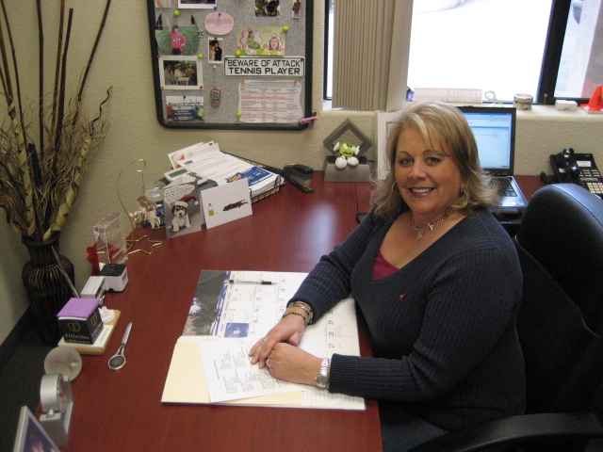

Adult Recreation and Competition is responsible for the development and administration of adult leagues and tournaments. The UST-/Nevada provides USTA Leagues under the governance of the United States Tennis Association, as well as local leagues. These leagues are designed to provide the opportunity for year-round competitive tennis in a team format and are designed to keep players in the game. Leagues provide play for Adult Men and Women (18 + years), Senior Men and Women (50 + years), Super Senior Men and Women (60 + years), as well as Mixed Doubles. League play accommodates play for players of all skill levels.

PARTICIPATION NUMBERS FOR USTA NEVADA

Year Participation Numbers
2005 5,285
2006 5,013
2007 5,040
2008 5,379
2009 6,047
2010 6,261

Annual Captains Meeting
The annual captains’ meeting was held at TAO nightclub with an attendance of 375 captains, co-captains and league participants. Each captain received a hooded sweatshirt with the USTA League crest on it. The guests were treated to free food and drinks for 3 hours, as well as GODIVA chocolates.

USTA – Nevada District Championships
Three District Championships were held at the Darling Tennis Center. 50 teams and over 575 players participated in the USTA Senior, USTA Mixed Doubles and USTA Adult District Championships. Each event offered food and refreshments everyday which was sponsored by the Adult League Department. The costs of these events were covered by the $50 team participation fee that was instituted in 2009.

Adult Awards Party- LAVO
600 USTA members were in attendance at the annual Adult Awards Party held at LAVO nightclub. Complimentary food and drinks were enjoyed by all. The event was very successful.

Ladies League Luncheon
The date for the annual Ladies League Luncheon was moved from May to October and was held in conjunction with the Lexus of Las Vegas Women’s Pro Circuit Tournament at Red Rock CC. The silent and live auction raised $2,500.

Rob Merriman, Junior Programs Coordinator
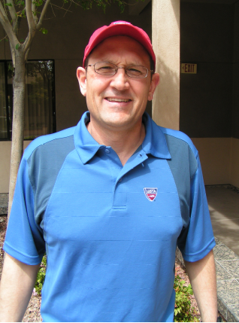 JUNIOR COMPETITION REPORT

2010 JUNIOR HIGHLIGHTS:

- The junior competition budget finished over $25,000 in the black.*
- Tactik Clothing and Connections Academy sponsored this year’s ITA Great Pumpkin, providing over $8,000 in support. Tactik also sponsored this year’s Elite League, providing $600 in support to cover shirt costs.

- Summerlin Tennis Club’s 14 & Under Intermediate team coached by Gordon Hammond, once again advanced to the Junior Team Tennis National Championships. Summerlin Team Member Mebeli Becerra was one of two players given this year’s Sportsmanship Award.

- Singles participation for both the Easter Circuit and Great Pumpkin were slightly up for 2010. Doubles participation for the Easter Circuit was up over 14%..

- Junior Team Tennis High School League participation was up over 16% compared to 2009..

- I ran four high school novice tournaments from May through August of this year. A total of 93 players competed in singles and 35 teams in doubles.

*As of the time of making this report, I did not have the year-end income statements. The net income figure is based on my income statement ending September 30, 2010 plus my expenses for October, November and December.

2006-2010 STATISTICS:

# OF SO. NV JRS RANKED SECTIONALLY & NATIONALLY
Final Sectional Ranking 2006: 149 Final National Ranking 2006: 71
Final Sectional Ranking 2007: 200 (+34.2%) Final National Ranking 2007: 76 (+7.04%)
Final Sectional Ranking 2008: 293 (+46.5%) Final National Ranking 2008: 95 (+25%)
Final Sectional Ranking 2009: 191 (-24.8%) Final National Ranking 2009: 90 (-4.9%)

DISTRICT SANCTIONED & NOVICE JR TOURN. PARTICIPATION
2006 Sanctioned: 1619 in singles 237 teams in doubles
2006 Novice: 563 in singles 12 teams in doubles
2007 Sanctioned: 1833 in singles (+13.2%) 84 teams in doubles (-64.5%)
2007 Novice: 532 in singles (-5.8%) 6 teams in doubles (-50%)
2008 Sanctioned: 1891 in singles (+3.1%) 272 teams in doubles (+223.9%)
2008 Novice: 475 in singles (-12%) 0 teams in doubles (-100%)
2009 Sanctioned: 1669 in singles (-11.7%) 284 teams in doubles (+4.4%)
2009 Novice: 531 in singles (+11.8%) 0 teams in doubles (no change)
2010 Futures: 554 in singles* (+4.3%) 35 teams in doubles*
2010 Sanctioned: 1653 in singles** (~=) 77 teams in doubles (-73%)

HIGH SCHOOL COACHES & PLAYERS CAMPS
2006 Coaches Camp: 10 2006 Players Camp: 61
2007 Coaches Camp: 12 2007 Players Camp: +80
2008 Coaches Camp: 6 2008 Players Camp: 62
2009 Coaches Camp: 7 2009 Players Camp: 83
2010 Coaches Camp: 8 2010 Players Camp: 86

EASTER CIRCUIT (EC) & GREAT PUMPKIN (GP) PARTICIPATION
EC ’06: 355 in singles, 84 teams in doubles. GP ’06: 428 in singles, 160 teams in doubles.
EC ’07: 399 in singles, 145 teams in doubles. GP ’07: 449 in singles, 179 teams in doubles.
EC ’08: 357 in singles, 136 teams in doubles. GP ’08: 338 in singles, 140 teams in doubles.
EC ’09: 324 in singles, 131 teams in doubles. GP ’09: 414 in singles, 192 teams in doubles.
EC ’10: 343 in singles, 152 teams in doubles GP ’10: 423 in singles, 185 teams in doubles

JUNIOR TEAM TENNIS PARTICIPATION (2006-2010)
2006: 377 2007: 452 2008: 583 2009: 455 2010: 285

Junior Team Tennis numbers were much lower than expected this year. I think this is due to the fact that the academy model of player development, which transitions players directly from in-house play to Futures Events, is replacing the old model of introductory lessons, recreational league play (Junior Team Tennis), followed by tournament play. Juniors are getting their competition within the structure of the academies, pros are making more money by keeping their players in-house, and the Futures are providing a ranking incentive for parents to have their children participate. Lastly, court usage is always an issue and if pros aren’t making money directly off the program, they are less likely to have their players participate. For 2011, I’m going to pursue a Junior Team Tennis tournament-based league; i.e. once or twice a month events will be held at a high school or middle school where all teams in that area will come together to compete at one location. I think this model is viable for the east side and could work for quickstart team competition on the west side.

*Includes the four high school novice tournies I ran from May through August.
**Includes estimated number of participants for the DTC Santa Claus and Anthem Shoot-Out, since at the time of writing this report, these events hadn’t been played yet.

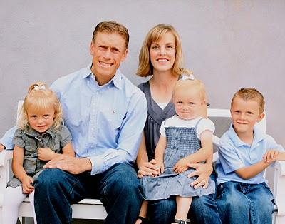
Dann Battistone (& Family)
Community Tennis & Diversity Coordinator Consultant
2010 HIGHLIGHTS

1 - PARKS AND RECREATION:
DESPITE THE ECONOMY, IT WAS STILL A RECORD YEAR FOR THE PARKS AND RECREATION PROGRAM. IN ONE OF THE 5 WEEK SESSIONS ALONE, WE WERE ABLE TO GROSS OVER $9,000 IN REVENUE. TOTAL REVENUE FOR THE YEAR WAS $41,738.

2 - HENDERSON QUICKSTART LEAGUE:
WE ARE KICKING OFF THE FIRST 10 & UNDER QUICK START LEAGUE EVER OFFERED IN HENDERSON. THE FIRST 6 WEEK SESSION STARTS THIS SATURDAY AT O’CALLAGHAN PARK. WE WILL OFFER NIKE UNIFORMS AND A FREE 1 YEAR JUNIOR USTA SUBSCRIPTION.
HENDERSON HAS WHOLEHEARTEDLY SUPPORTED US BY OFFERING US A KEY SPOT IN THEIR ‘HENDERSON HAPPENINGS’ BROCHURE AS WELL AS MASS DISTRIBUTING A CUSTOM FLYER ABOUT THE PROGRAM TO ITS CITIZENS.

3 - TRAINING & DIVERSITY
WE WERE ABLE TRAIN OVER 100 COACHES AND TEACHERS THROUGH 2 COACHES WORKSHOPS AND 1 TEACHER IN-SERVICE. THOSE TRAINED WERE FROM MANY DIFFERENT ETHNIC BACKGROUNDS, REPRESENTING MANY DIFFERENT SCHOOLS AND NATIONALITIES. RYAN AND THE USTA ALSO HELD TWO ADDITIONAL WORKSHOPS FOR OUR COACHES...WITH 5 QUALITY WORKSHOPS IN 2010, WE HAVE SOME OF THE BEST TRAINED COACHES IN THE NATION.

4 - TEACHING PRO COMPENSATION
IN AN EFFORT TO BETTER SERVE OUR PROS, WE IMPROVED OUR CURRENT SYSTEM WHERE OUR PROS ARE ABLE TO GET THEIR CHECKS 2-3 WEEKS EARLIER THAN THEY USED TO. IF WE KEEP OUR PROS HAPPY AND MOTIVATED, THEY WILL BE BETTER ABLE TO HELP GROW THE GAME OF TENNIS WITH US.

5 - ACCOUNTING AND PAYROLL
IN AN EFFORT TO IMPROVE SECURITY AND CONFIDENTIALITY OF PAYROLL AND FINANCIAL INFORMATION, WE PUT ADDITIONAL CONTROLS IN PLACE TO KEEP THIS INFORMATION PRIVATE. WE HAVE MOVED THE PAYROLL FUNCTION COMPLETELY PAPERLESS AND OFFSITE. THERE ARE MANY OTHER IMPROVEMENTS THAT WE CAN MAKE TO THE ACCOUNTING PROCESSES IN 2011 THAT WILL INCREASE SECURITY AND PROVIDE BETTER SERVICE TO OUR MEMBERS.

USTA- NEVADA STAFF 2010

Ryan Wolfington, Executive Director

Rob Merriman, Junior Programs Coordinator

Mary Maragos, District League Coordinator

Dann Battistone, Community Tennis & Diversity Coordinator

Diana Winn, Administrative Assistant/Office Manager

Southern Nevada USTA Membership
Dates | Adults | Juniors | Total
12/31/2000 | 2637 | 676 | 3313
12/31/2001 | 2881 | 260 | 3141
12/31/2002 | 2939 | 835 | 3774
12/31/2003 | 3022 | 894 | 3916
12/31/2004 | 2956 | 669 | 3625
12/31/2005 | 3168 | 642 | 3810
12/31/2006 | 3164 | 765 | 3929
12/31/2007 | 3287 | 782 | 4069
12/31/2008 | 3324 | 793 | 4117
11/30/2009 | 3479 | 813 | 4292
12/31/2010 | 3513 | 796 | 4321

